Home Assignment 2:
LangChain Persistent Memory with MongoDB
Implemented so far
Front end
- Added a Test Case Generator screen using the existing RAG and LLM services.
- Added a generation form and display for generated test cases, including their saved response metadata.
- Added persistent conversation handling in the browser:
  - Starts a conversation with a UUID.
  - Saves the active conversation ID in browser local storage.
  - Reuses the ID for subsequent generation requests.
  - Allows the user to start a new conversation.
- Added a Saved conversations panel with refresh and pagination.
- Added the ability to open a saved conversation and restore its conversation ID, generation history, generated test cases, and conversation-specific counts.
- Added global and current-conversation MongoDB counts for memory documents, generation-history records, and completed generations.
- Added a guarded conversation-delete flow that requires exact ID confirmation.
- Fixed the counts refresh buttons so they no longer send the click event as the conversation ID.
Back end
- Added POST /api/test-cases/generate for test-case generation:
  - Uses the existing LLM service and its fallback behavior.
  - Uses the existing hybrid BM25 and vector retrieval.
  - Accepts an existing conversation ID to continue a conversation or creates one when needed.
  - Persists conversation messages and generation history.
- Integrated LangChain’s MongoDB-backed chat message history to load and save conversation context.
- Added separate MongoDB collections for:
  - conversation_memory — persistent LangChain conversation messages.
  - test_case_generation_history — generation requests and results.
- Added unique conversation, execution, and memory-record IDs, along with generation timestamps and metadata.
- Added APIs to retrieve global or conversation-specific counts and to delete a specific conversation’s memory and history.
- Added paginated conversation listing and conversation-detail APIs, returning saved messages, generation records, generated test cases, and metadata.
- Added UUID and pagination input validation and bounded the amount of history returned by the detail API.
Validation and documentation
- Added focused tests for persistence, conversation isolation, counts, deletion, listing, saved conversation loading, and generation behavior.
- The latest reported memory test run passed 17/17 tests; the frontend build succeeded. The build continues to show an existing large-bundle warning.
- Documented the phases, API contracts, and UI/API/MongoDB validation steps in LANGCHAIN_PERSISTENT_MEMORY_PLAN.md.
Operational note: The history APIs do not implement authentication, so they should remain behind a trusted network or authentication layer. Conversation deletion uses a MongoDB transaction and therefore requires a MongoDB deployment that supports transactions.

Postman check for this implementation :
1.Add the history:
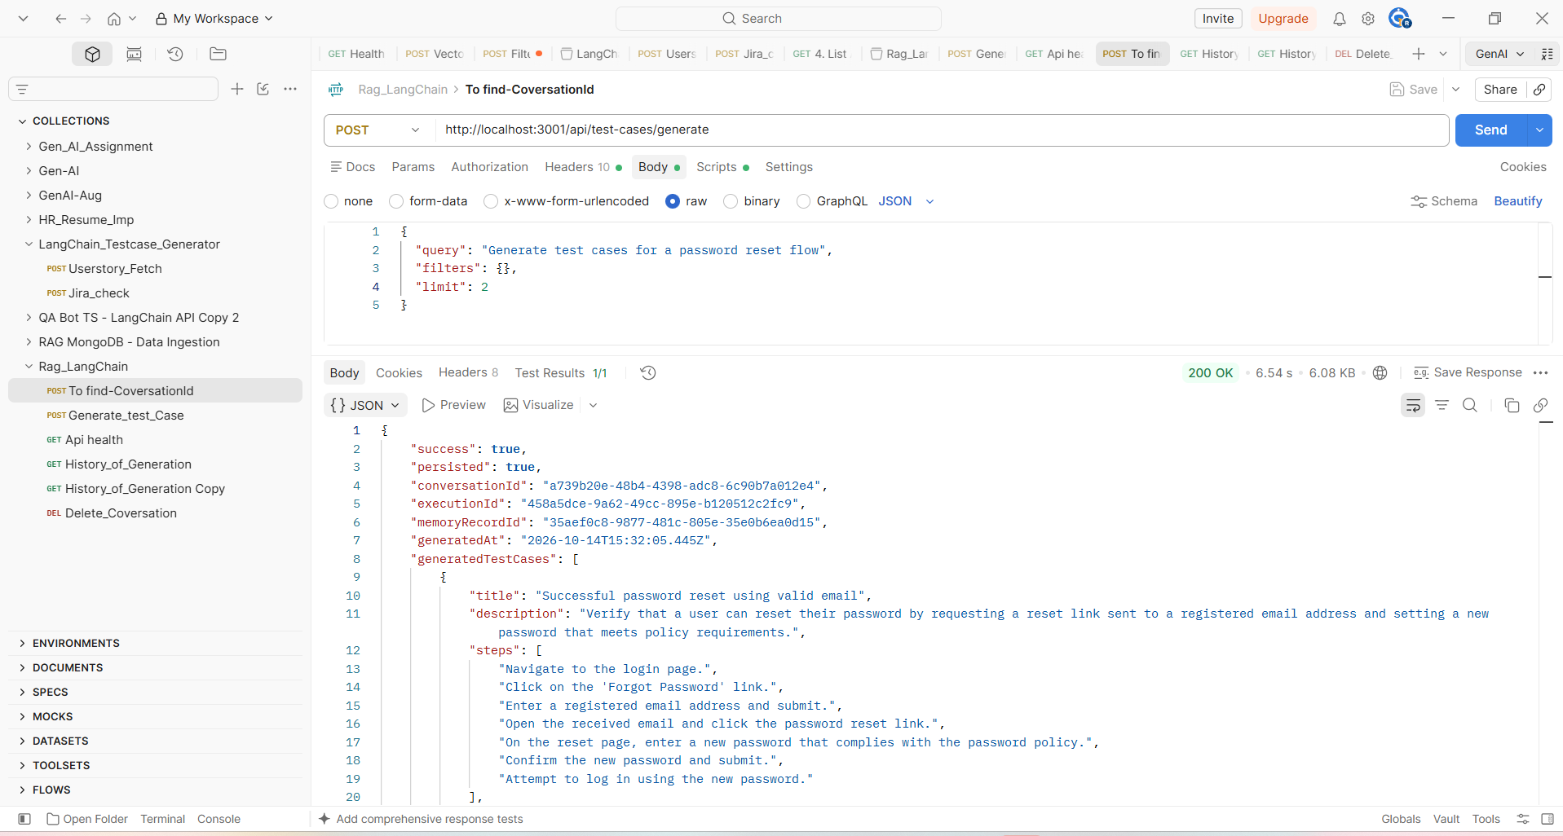

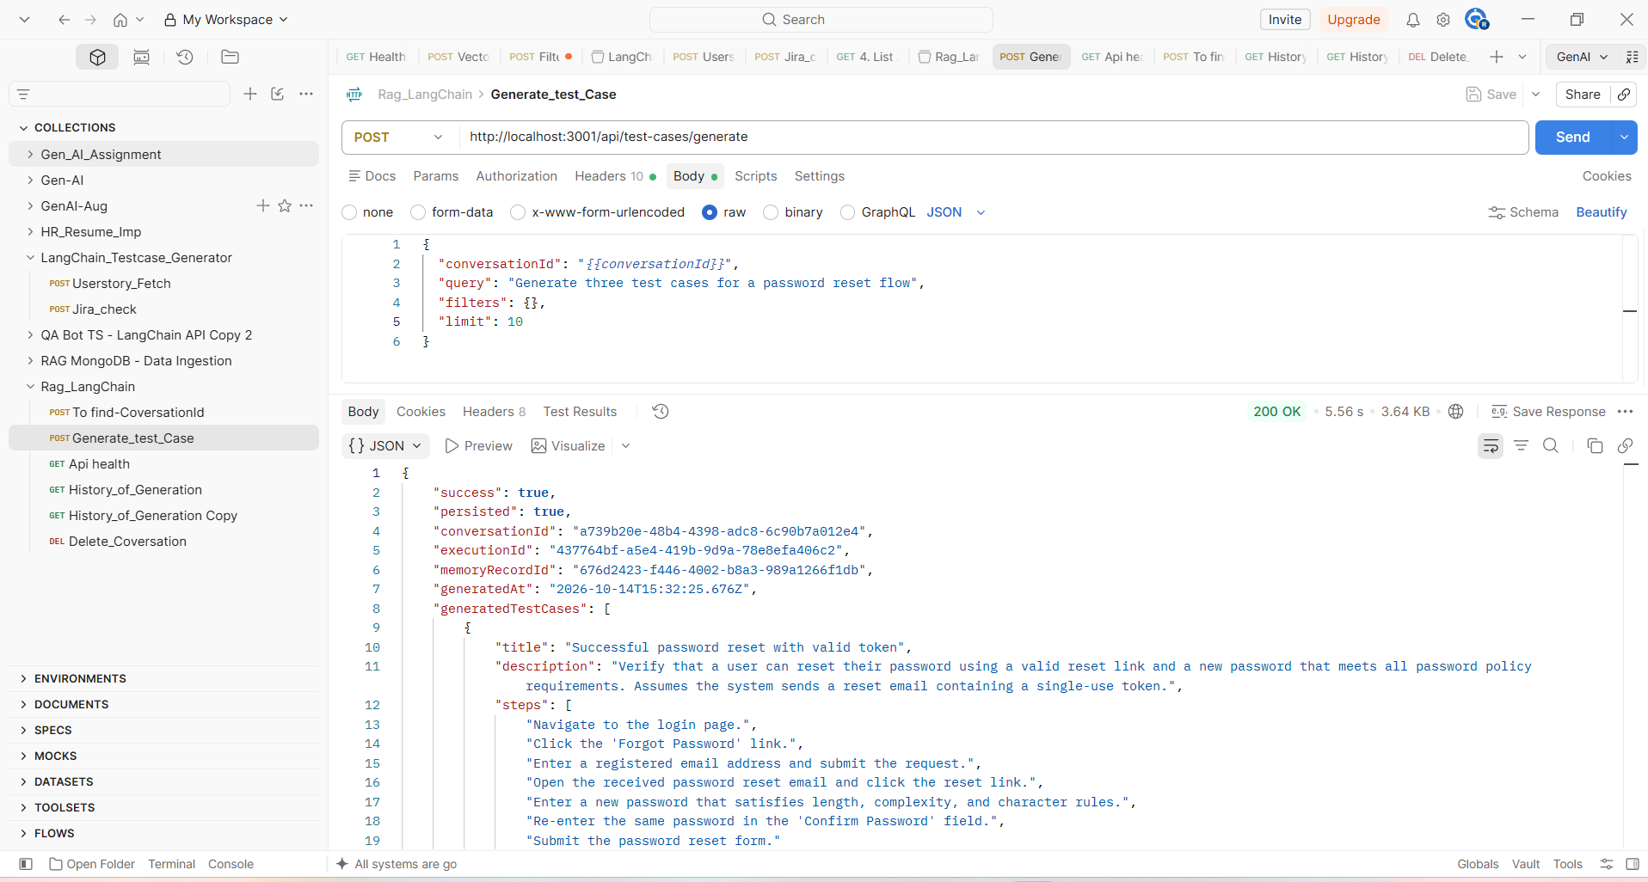
2.Delete the single id history :
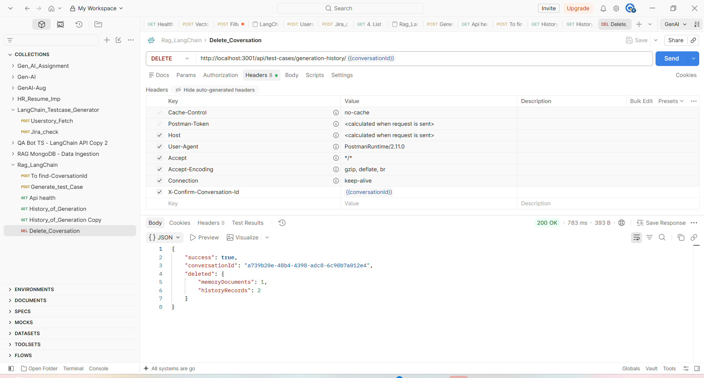
3.Get the history :
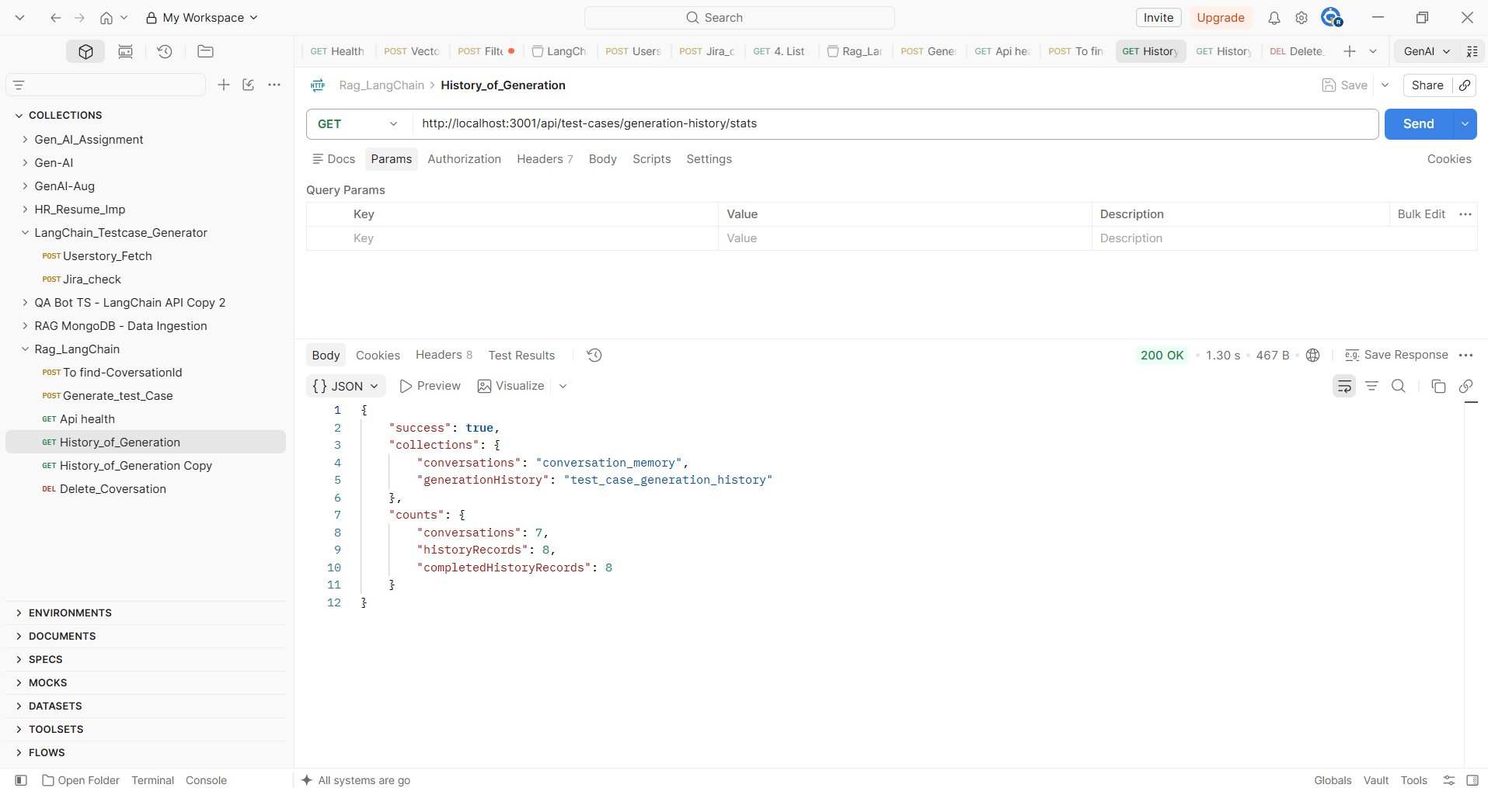
Validation In mangodB:
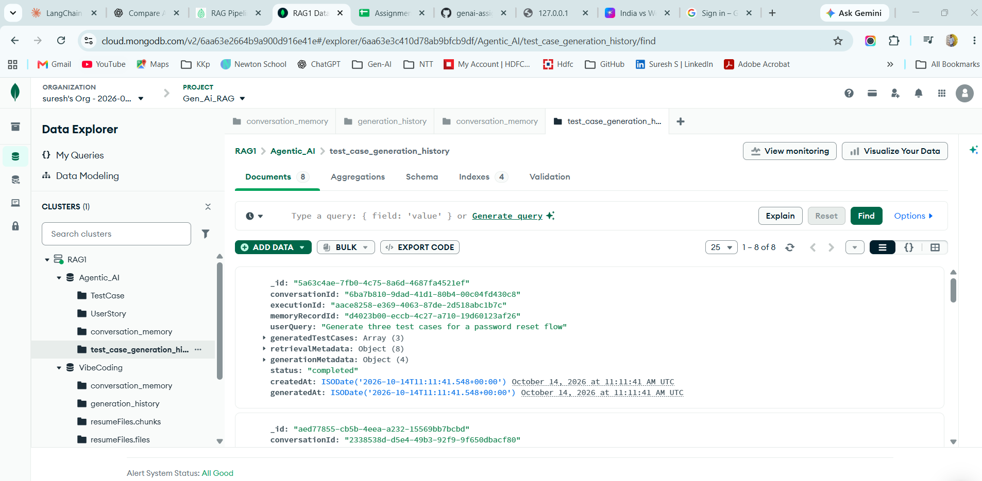
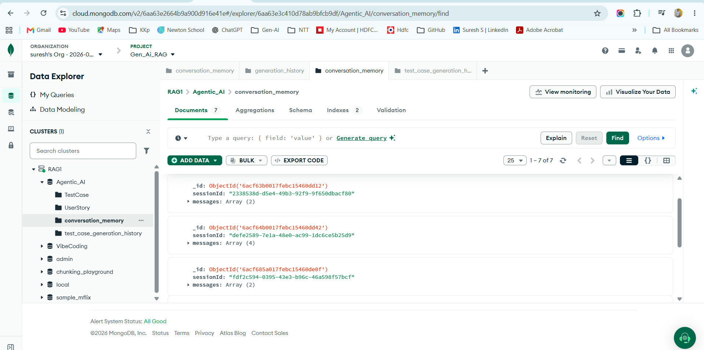
After delete :
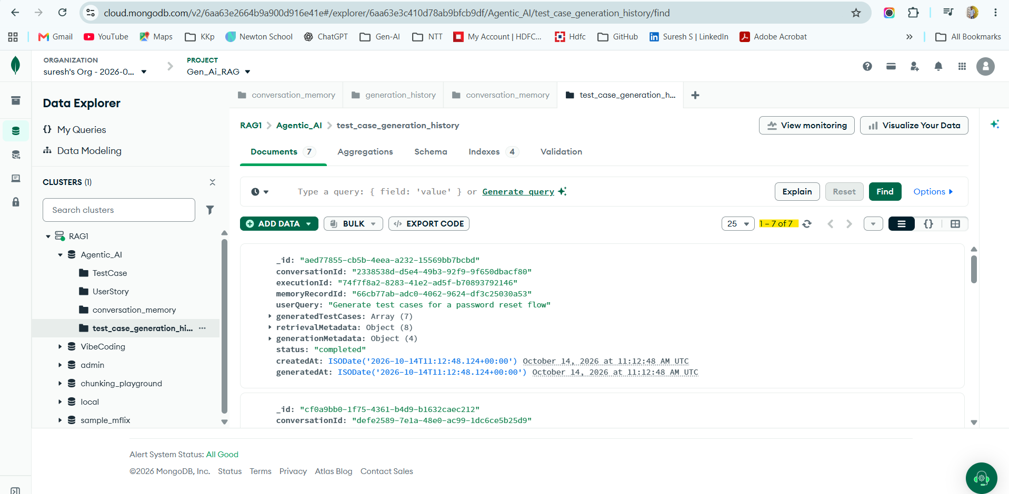

UI Implementation:
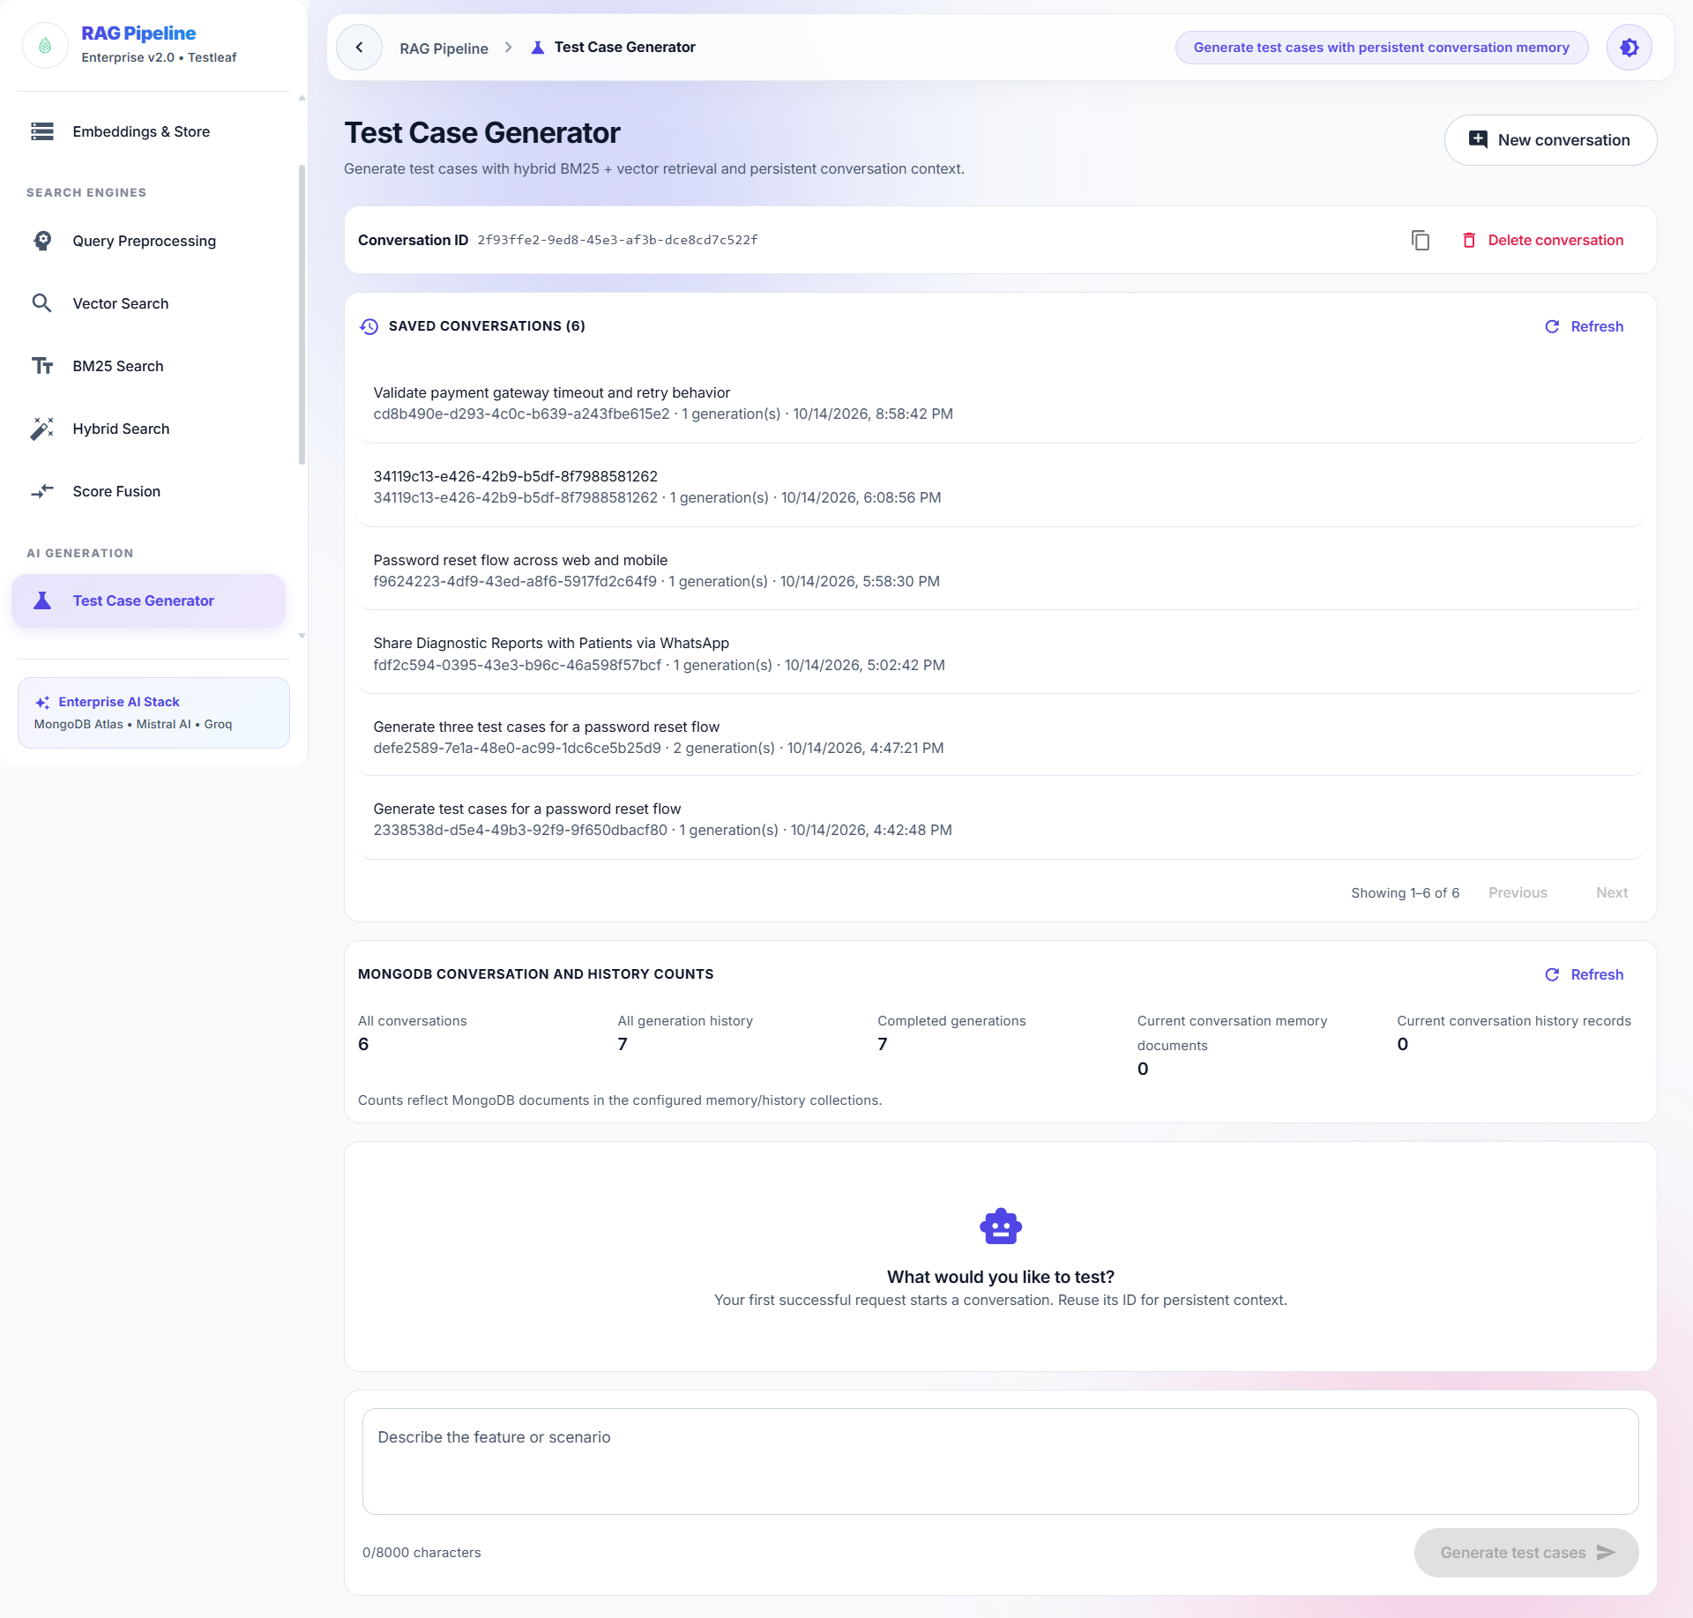
Test case generation:
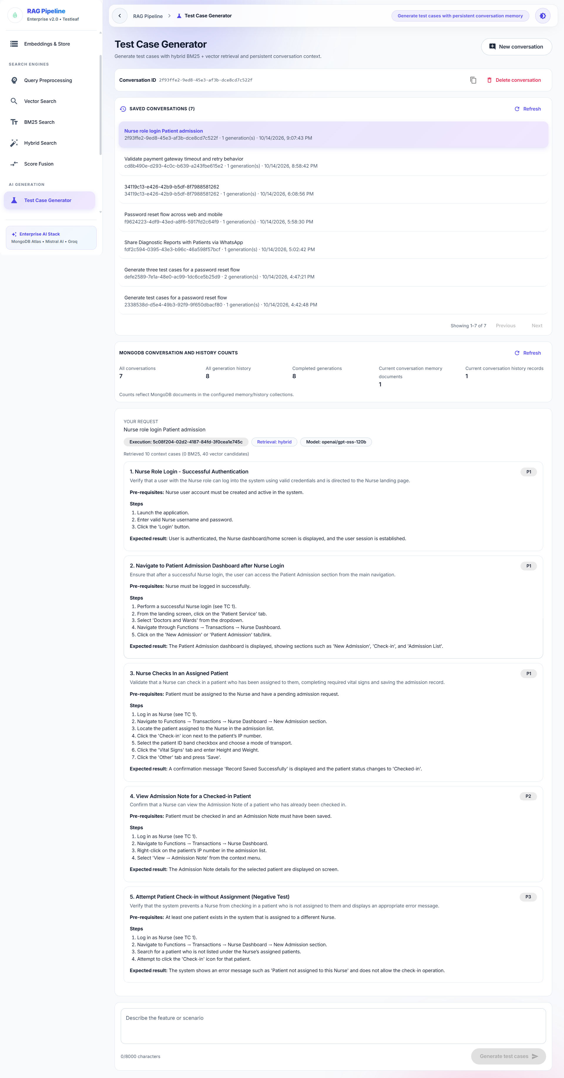
Validate in Mango DB:
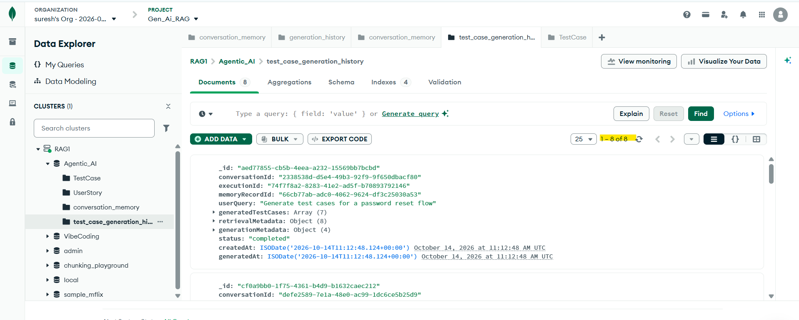
Delete from UI:
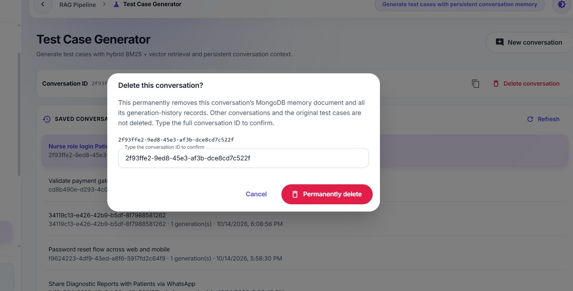
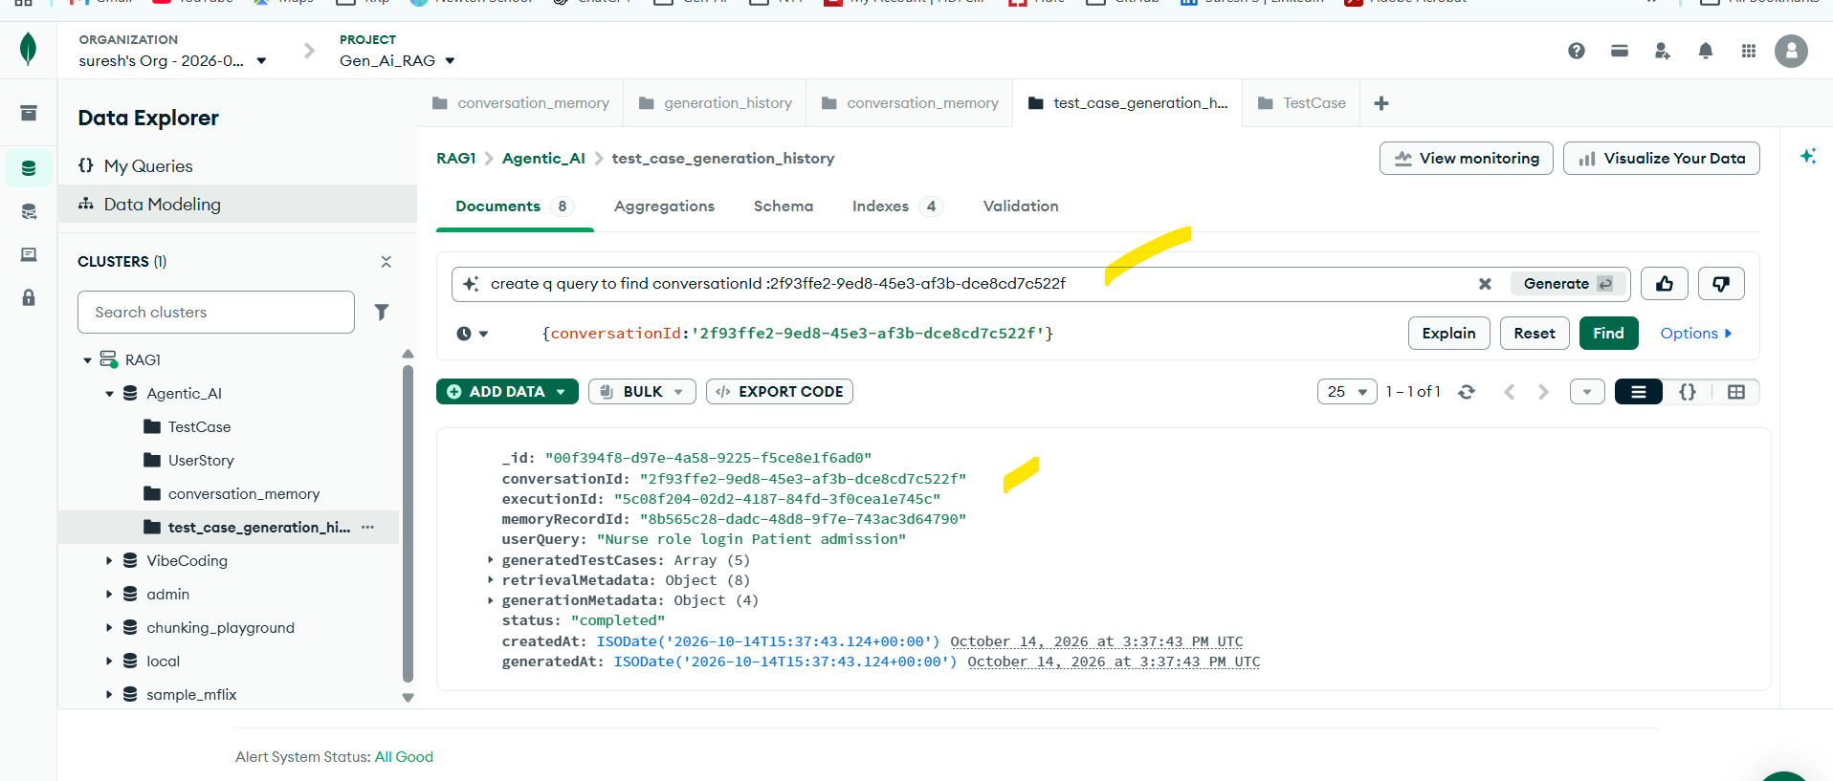

After successful delete :
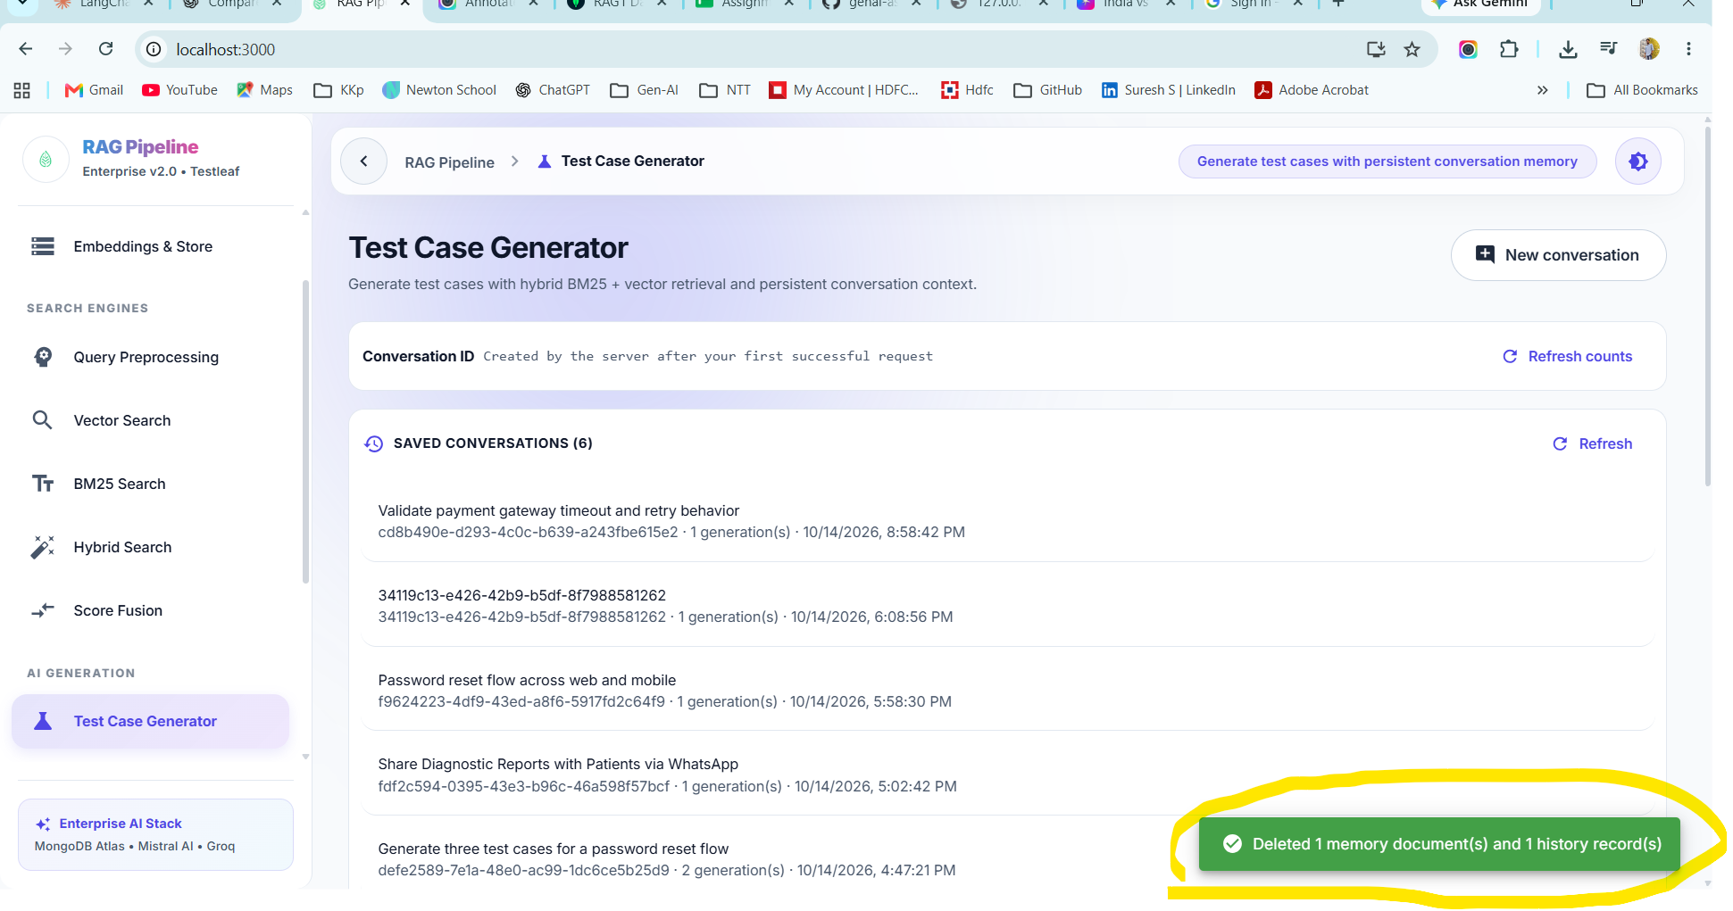
DB:
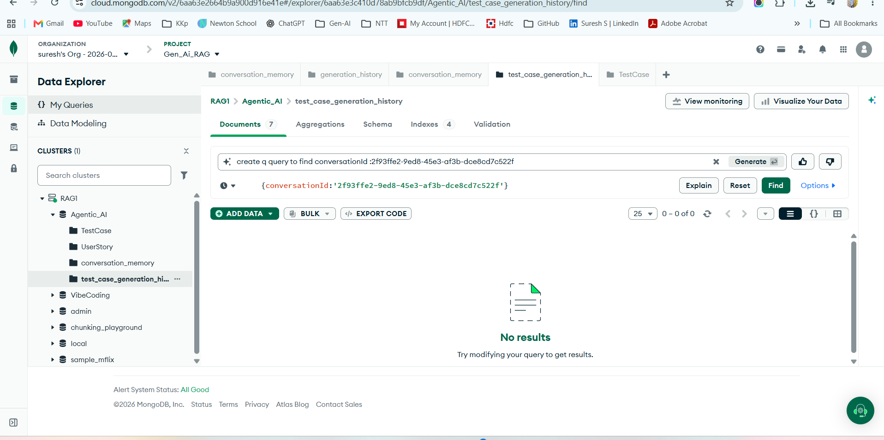
Increase the conversation history from UI:
Before creation:
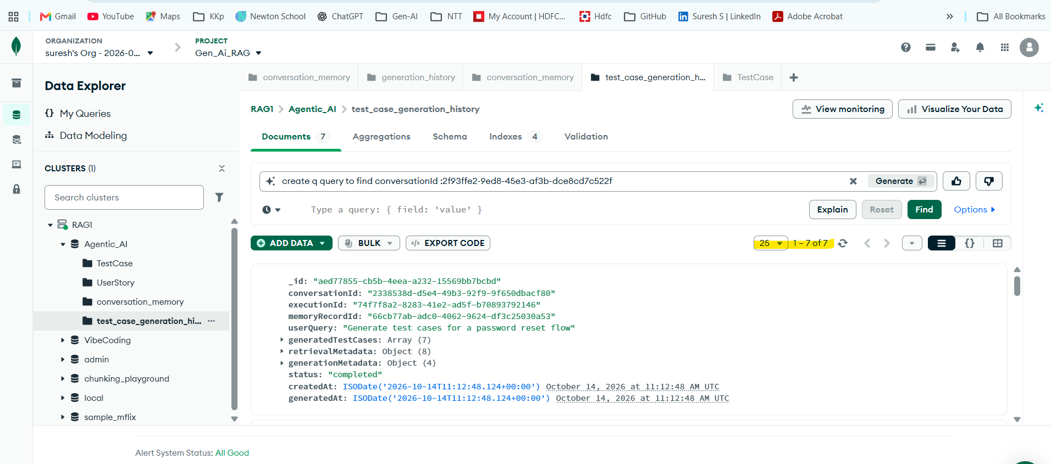
after addition:
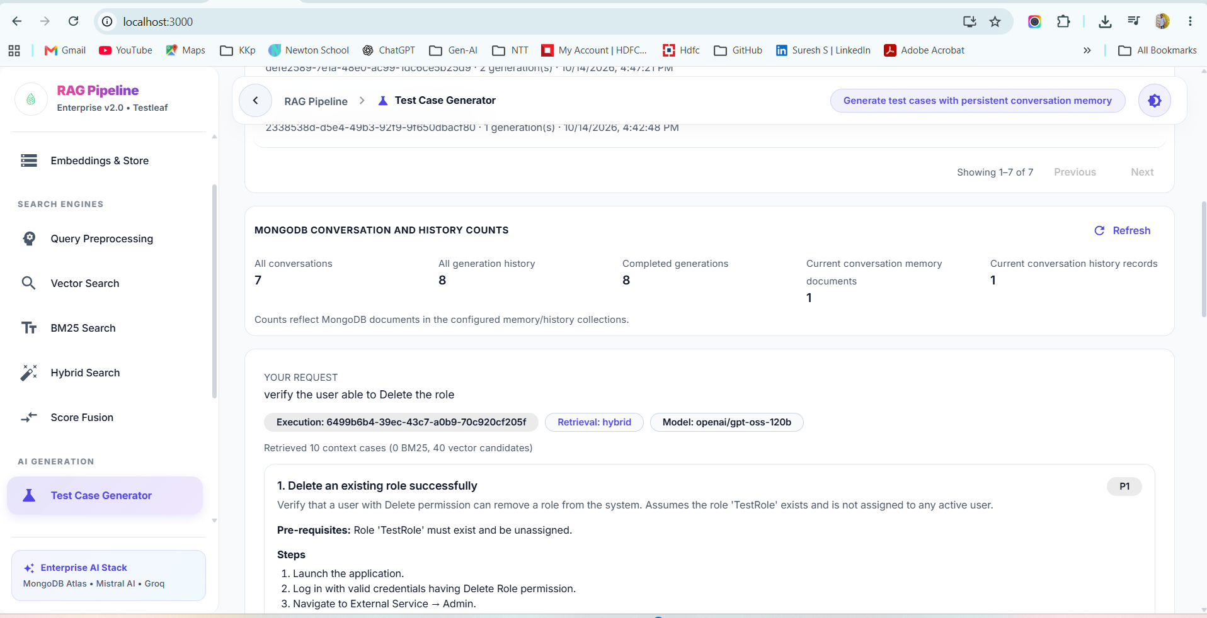
DB:
